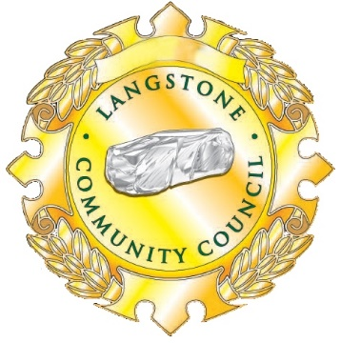

GRANTS and awards POLICY

Langstone Community Council will consider applications for grants that they consider are permissible within their statutory powers from Registered Charities, Voluntary Groups or Community Organisations.
To qualify for an award, the applicant must be able to demonstrate that any funding from the Council will benefit the Community of Langstone, Llandevaud and/or Llanmartin. Grant applications will be considered by the Finance and Development Committee which meets in November. Dates and times are available from the Clerk or from the Community Council website.
The applicant is welcome to attend the meeting at which the application is to be considered and at the Chairman’s discretion may address the Councillors to give background and futher information for a maximum period of three minutes.
Applications should be in writing, preferably on the attached form, and sent to the Clerk.

Barradell Award
The purpose of the Barradell Award is to acknowledge and reward outstanding contribution to the community by a group or charity, in memory of Councillor David Barradell. Of the grants awarded, one or two may be selected by the Council to receive an additional payment in recognition of their special contribution. Their award will be presented by Mrs Ann Barradell at the LCC Christmas Concert.

purpose of grant

- Purchasing equipment either in part or in full.
- Funding of transport that will enable group members to partake in a group trip or outing regardless of their incomes.
- Contributing toward running costs of a group/organisation serving parishioners.
- Training activities, or to purchase the expertise of an outside trainer/ instructor/ facilitator.
- Activities that raise the profile of the area.
- Hosting special events or celebrations.
- Provision of recreational facilities.

Conditions

- Grants may not be awarded to individuals
- Additional applications within a 12 month period will not normally be considered.
- The award must be used for the purpose for which the application was made.
- If the group is unable to use the award for the stated purpose, all monies must be returned to the Council.
- All awards must be properly accounted for and evidence of expenditure should be supplied if requested. If the Council is not satisfied with the arrangements, they reserve the right to request a refund of monies awarded.
- Donations to Registered Charities in response to a general fundraising appeal will normally be restricted to an upper limit of £100.

Eligibility

- Any Registered Charity, Voluntary Group or Community Organisation.
- Agencies that operate within Langstone, Llandevaud and/or Llanmartin and are of benefit to the local community, with the following provisos:
- The Council will not fund activities that it considers to be the responsibility of a Statutory Authority.
- Applications from schools for an activity that takes place within the school day will not be considered.
- The Council cannot fund activities outside its legally defined powers and functions.
GRANT APPLICATION FORM
Name of organisation
Registered Charity Number
(if applicable)
Group Contact | Name
 | Position / Role
 | Address
 | Telephone number
 | Email address
Number of members in the Group
Bank  Account  Details  (for payment  of grant) |  | Sort Code
 |  | Account No
 |  | Account Name
What will the grant be used for?

How will it benefit Langstone residents?

Name and Contact Details of person nominating the above organisation (if different from main contact) |  |  | Name
 |  |  | Address
 |  |  | Tel No
 |  |  | Email
Return completed form to Heather Jones, Langstone Community Council, Merlin House, Langstone Business Park, Newport NP18 2HJ Email: clerk@langstonecommunitycouncil.org.uk

