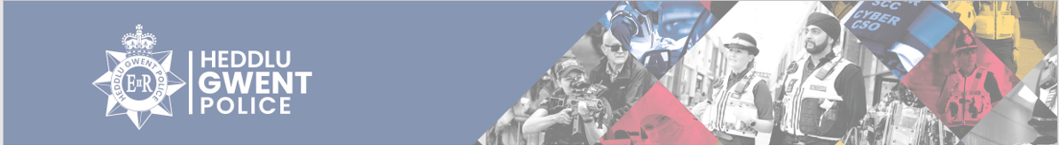
Langstone Ward
There have been 165 total number of calls for the Langstone Ward from 1st October – 31st October 2025. Some of these calls are reported more than once at the time of the incident or could be related to the motorway.
Within Gwent Police, the Langstone ward consists of the area shown in the map below.
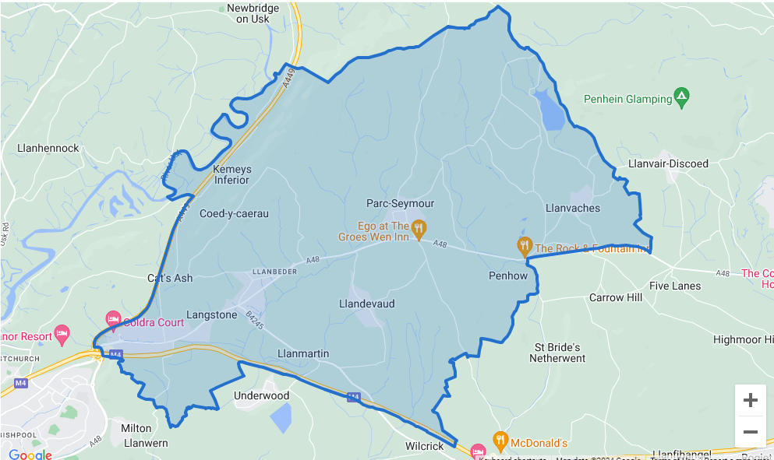
Below is a breakdown of some of the calls reported to the area;
- Concern for safety – 7 – Abandoned calls, concerns for members of the public, welfare checks conducted, and Referrals put in were needed.
- Violence – 8– Reports of threats, harassment, verbal arguments, and assaults. These are ongoing investigations.
- Off Road Bikes – 3– Observation passed to officers.
- Highway Disruption – 2 – Reports of broken-down vehicles and vehicles causing obstruction.
- Missing person – 0
- Care homes – 16 - All missing persons were from children’s homes and located safe and well.
- Road related incident – 10 – Reports of possible dangerous driving, driving without MOT or insurance and road traffic collision. 1 vehicle seized.
- Suspicious circumstances – 8 – Suspicious persons and suspicious vehicles. Observations passed and patrols carried out.
- Drugs – 1 – Intel submitted.
- Theft – 2 – Theft of number plates
- Criminal Damage – 4 – Damage to fence, wall, trees, and vehicles.
- Burglary – 2 – Male trying door handles.
- Robbery – 1 – On going investigation.

Contact Information

Residents can contact us directly for advice and guidance on the below, however incidents must be reported on 101 or 999 in emergencies.
CSO Daniel Sutherland – daniel.sutherland@gwent.police.uk

