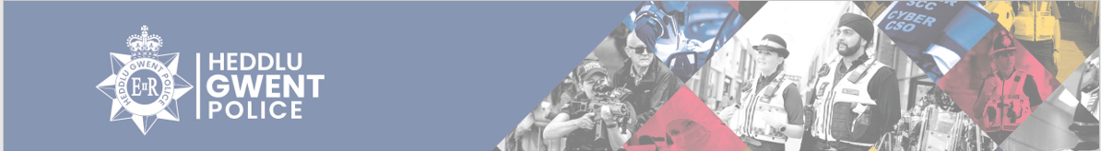
Langstone Ward
There have been 121 total number of calls for the Langstone Ward from 1st January – 31st January 2026. Some of these calls are reported more than once at the time of the incident or could be related to the motorway.
Within Gwent Police, the Langstone ward consists of the area shown in the map below.
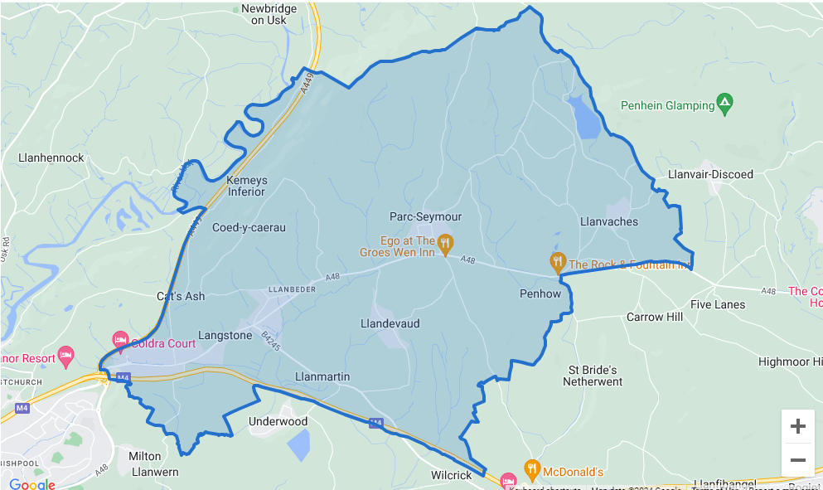
Below is a breakdown of some of the calls reported to the area;
- Concern for safety – 7 – Abandoned calls, concerns for members of the public, welfare checks conducted, and Referrals put in were needed.
- Violence – 8– Reports of threats, harassment, verbal arguments, malicious communications, and assaults. These are ongoing investigations.
- Animal Welfare – 1
- Highway Disruption –14 – Reports of broken-down vehicles, vehicles causing obstruction, debris in the road and fallen tree.
- Missing person – 1 - Located safe and well
- Care homes – 2 - All missing persons were from children’s homes and located safe and well.
- Road related incident – 1– Reports of road traffic collision.
- Suspicious circumstances – 4 – Suspicious persons and suspicious vehicles. Observations passed and patrols carried out.
- Theft – 2 – Theft of food and chocolate.
Contact Information

Residents can contact us directly for advice and guidance on the below, however incidents must be reported on 101 or 999 in emergencies.
PCSO Daniel Sutherland – daniel.sutherland@gwent.police.uk
PCSO Rebecca Dickson – Rebecca.dickson@gwent.police.uk

