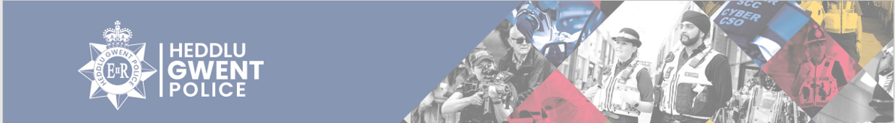
Langstone Ward
There have been 161 total number of calls for the Langstone Ward from 1st March – 31st March 2026. Some of these calls are reported more than once at the time of the incident or could be related to the M4 and A449.
Within Gwent Police, the Langstone ward consists of the area shown in the map below.
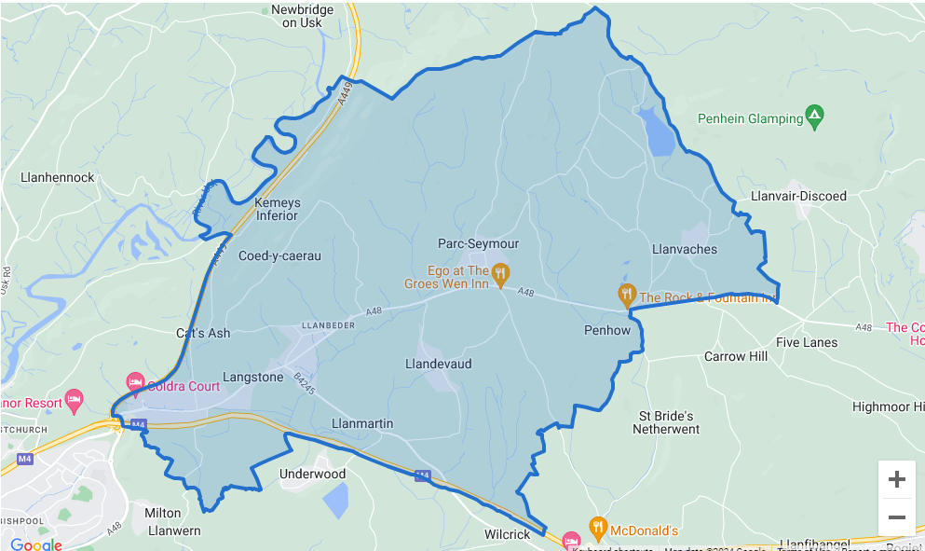
Below is a breakdown of some of the calls reported to the area;
- Concern for safety – 7 – Abandoned calls, concerns for members of the public, welfare checks conducted, and Referrals put in were needed.
- Violence – 9– Reports of threats, harassment, verbal arguments, and assaults. These are ongoing investigations.
- Criminal Damage – 1 – Vehicle damaged.
- Highway Disruption –5 – Reports of vehicles causing obstructions, abandoned vehicles and animals in the road.
- Missing person – 0-
- Care homes – 15 - All missing persons were from children’s homes and located safe and well.
- Road related incident – 6– Reports of road traffic collision, dangerous driving and driving under the influence. 2 vehicles seized and one person report for driving offences.
- Suspicious circumstances – 7 – Suspicious persons, suspicious vehicles and suspicious canisters. Observations passed and patrols carried out.
- Nuisance – 2 – Issue with guest’s causing problems.
- Burglary – 1 – Attempt break into property.
- Environmental – 1 – Report of fly tipping
- Animal/Welfare – 1
- Neighbourhood Dispute – 1
- Off road bikes – 2 - Observations passed to officers and officers attending the areas for patrols.

Contact Information

Residents can contact us directly for advice and guidance on the below, however incidents must be reported on 101 or 999 in emergencies.
PCSO Daniel Sutherland – daniel.sutherland@gwent.police.uk
PCSO Rebecca Dickson – Rebecca.dickson@gwent.police.uk

